# **Introduction**

Bangalore is the capital of the Indian state of Karnataka. It has a population of over ten million, making it a megacity and the third-most populous city and fifth-most populous urban agglomeration in India. It is located in southern India, on the Deccan Plateau at an elevation of over 900 m (3,000 ft) above sea level, which is the highest among India's major cities.Its multi-ethnic, multi-religious, and cosmopolitan nature is reflected in the varied cuisines serving restaurants. The diversity of cuisine is reflective of the social and economic diversity of Bangalore.Bangalore has a wide and varied mix of restaurant types and cuisines and Bangaloreans deem eating out as an intrinsic part of their culture. Roadside vendors, tea stalls, and South Indian, North Indian, Chinese and Western fast food are all very popular in the city. Bangalore is also 'Silicon valley of India'. In this assignment, we are doing a survey of famous cafe locations of the famous 'IT hub' of India.Having said that, lot of people from all over India settle in the silicon valley for jobs. So as part of this project , we will list and visualize all major parts of Bangalore that has great cafes and restaurants and I will suggest where we can open a new cafe if someone is looking to open a business.

### **Data**

For this project we need the following data :

* Zomato api data (zomato.csv dataset)
* Foursquare api to derive venues for neighbourhood information
* GeoSpace data - Latitude,longitude for given cafes

### **Approach**

* Collect bangalore restaurant data from zomato api
* Filter out all venues that are cafes.
* Using geopy find latitude and longitude for given cafes.
* Using FourSquare API we will find all venues for each neighborhood.
* Using rating for each restaurant , we will sort that data.
* Cluster using appropriate algorithm
* Visualize the Ranking of neighborhoods using folium library(python)

### **Use Cases**

* What is best location in Bangalore for cafes ?
* Which all areas lack cafes ?
* Which areas have potential cafes?
* Which is the best place to stay if I prefer cafes in the city?

## **Import important libraries**

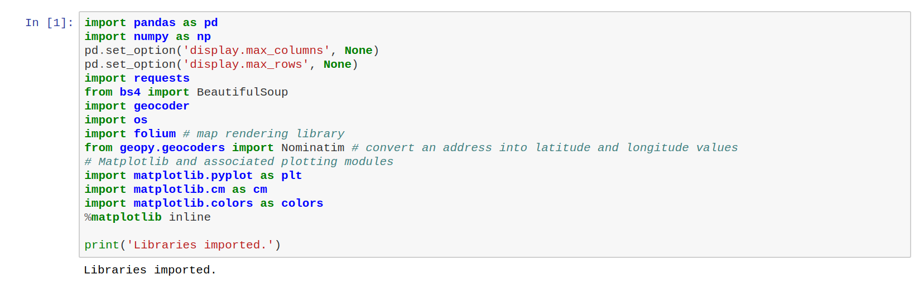

**Working with the data**

Read the data and get the shape and column names of the dataset

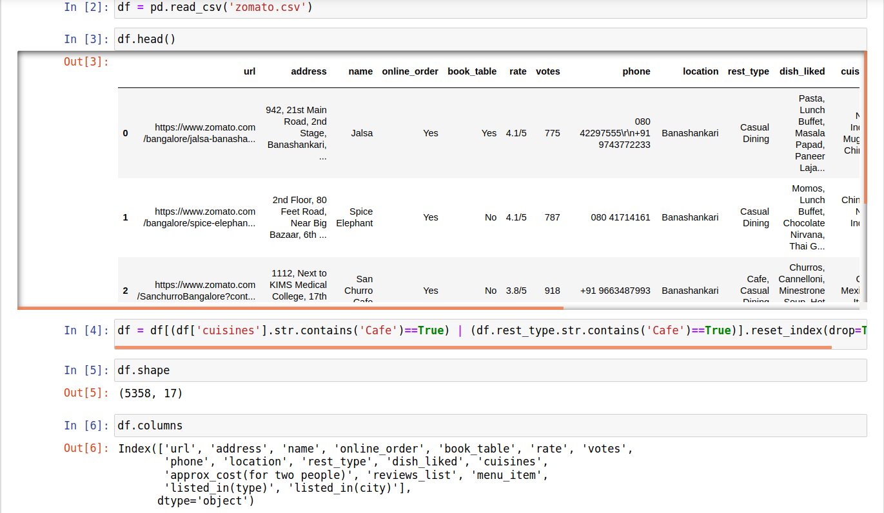

To work on the data, we selected the 4 columns - 'address','name','rate','location'

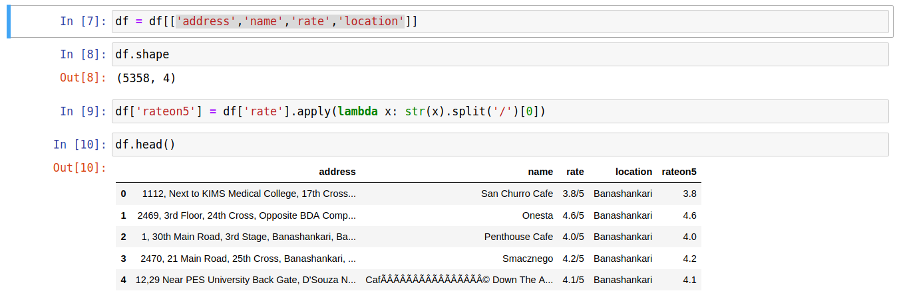

Next we find the coordinates of the locations we found through the data set

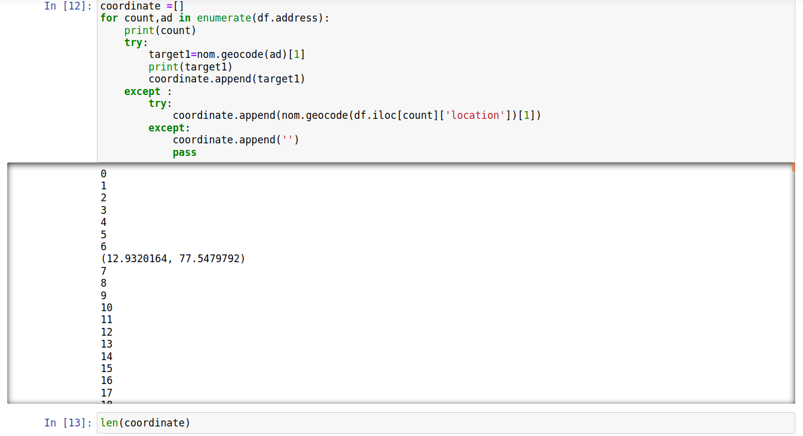

As the data is less now we integrate and explore the neighborhoods using Foursquare api.

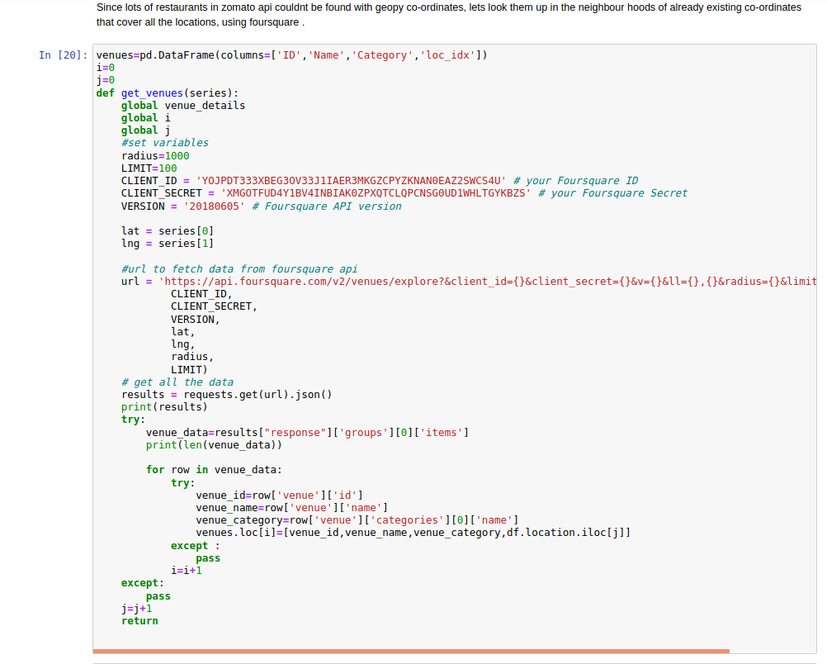

Let's sort the data on the basis of the Restaurant types - ‘Cafeteria','Café','Breakfast Spot'

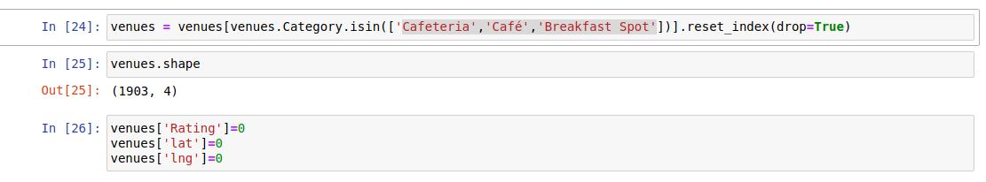

Created a method to get the venue details using the foursquare api and sort it on id, name, latitude, longitude and ratings of the cafe

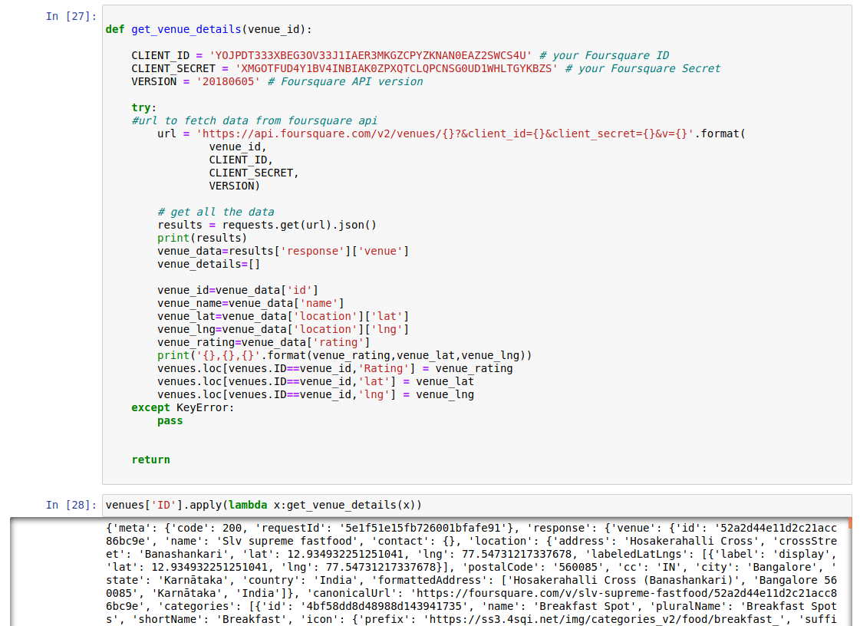

Get the unique locations of Bangalore where there are cafes.

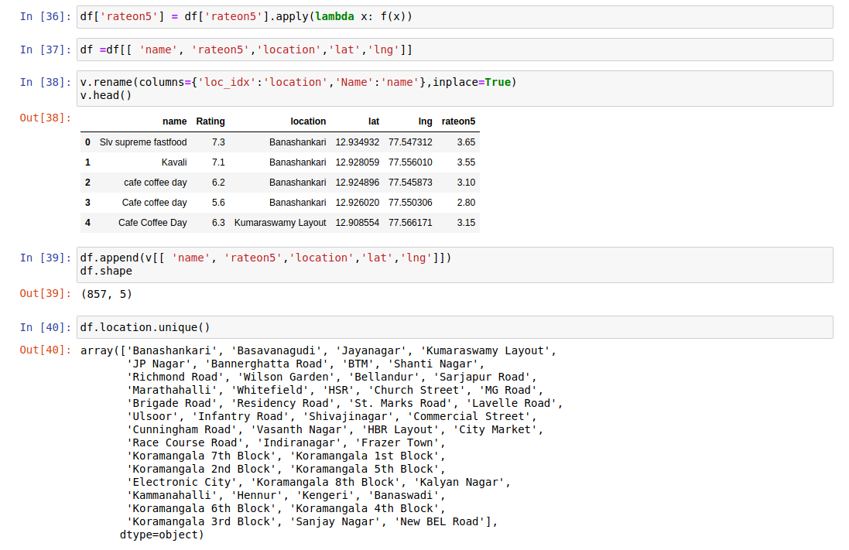

Basis on the rating on 5, lets plot the graph and see which area has better cafes

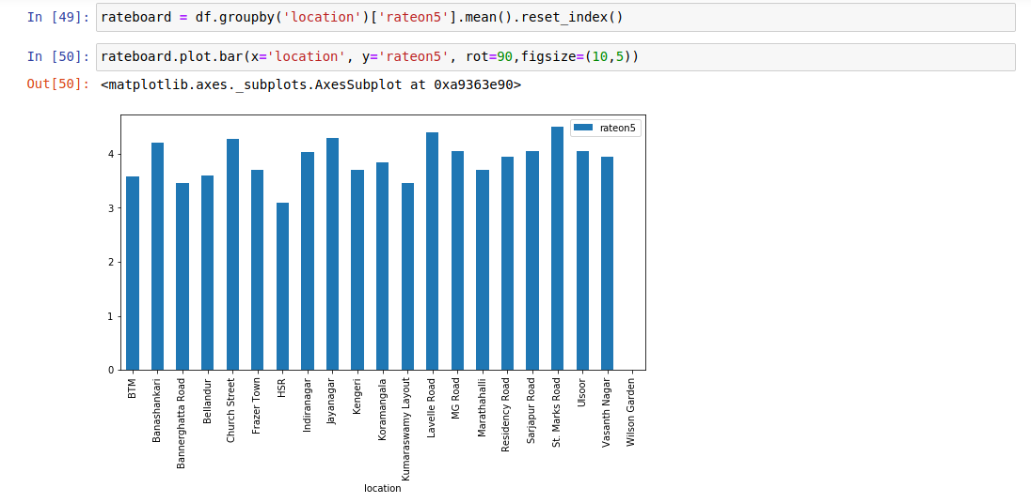

In a similar way let's get the name of the areas where there are better cafes.

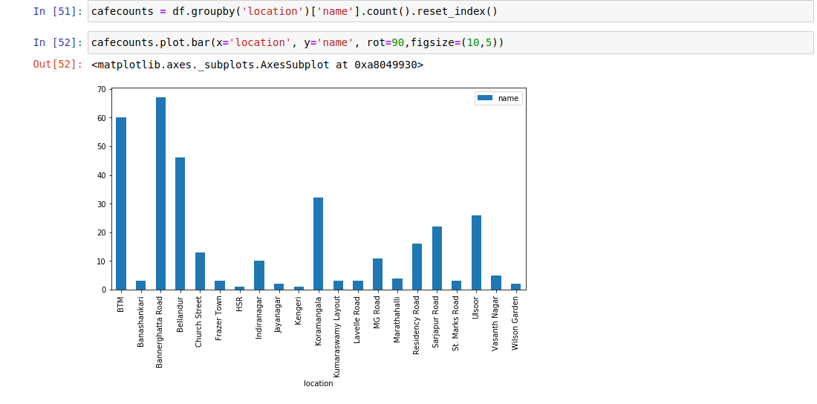

Filter out the locations where there are cafes and from which how many are better cafes based on the ratings

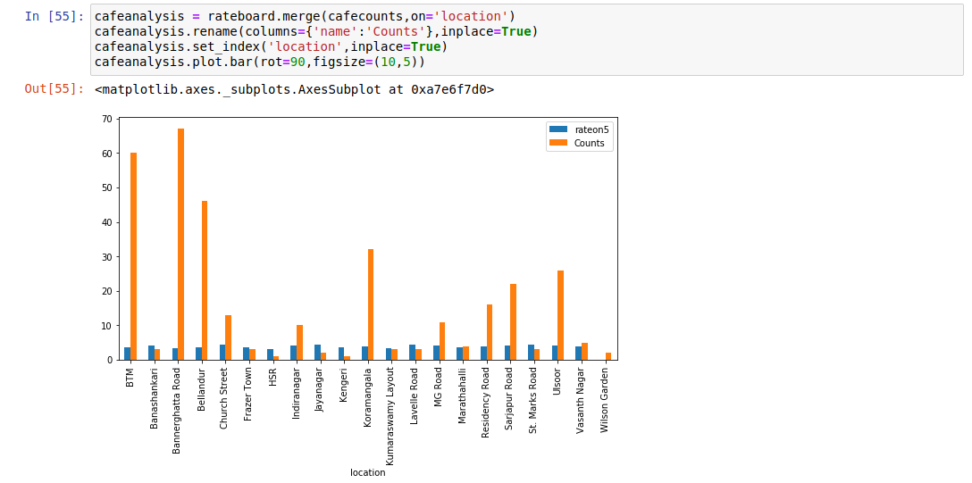

Let’s use KMeans clustering to group similar cafes in different areas of Bangalore

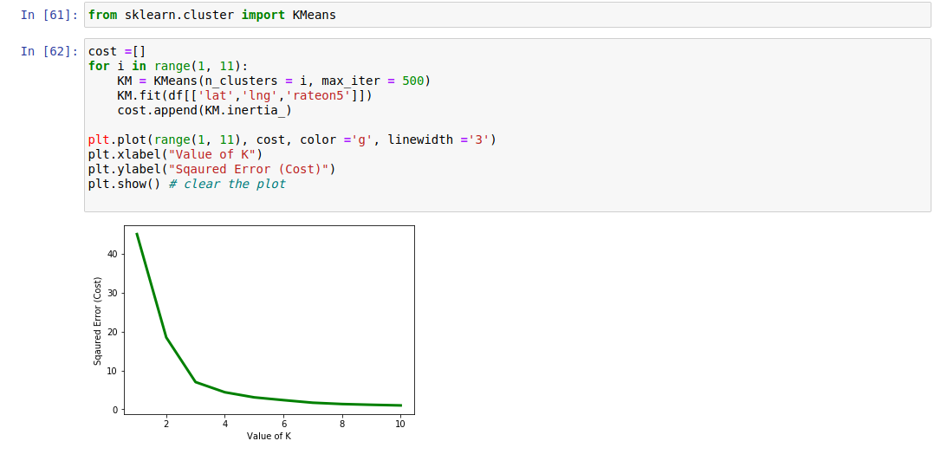

Plot the incidents, places where there are good cafes using Folium maps

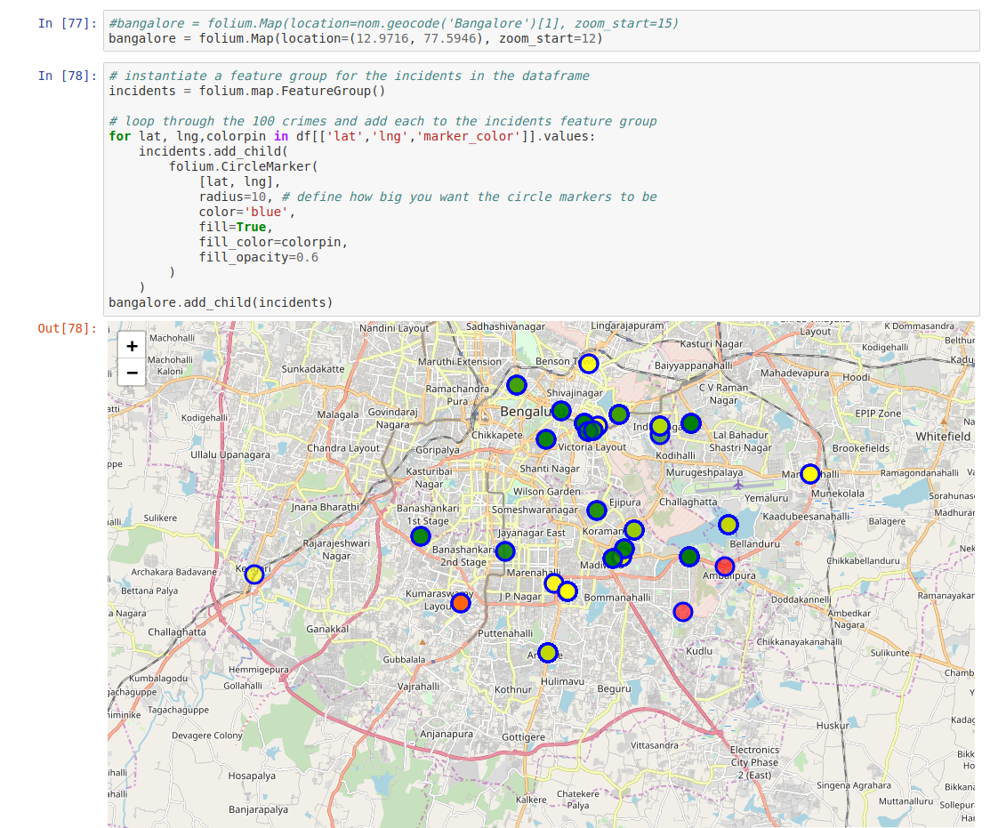

Markers indicating the exact location of the cafes

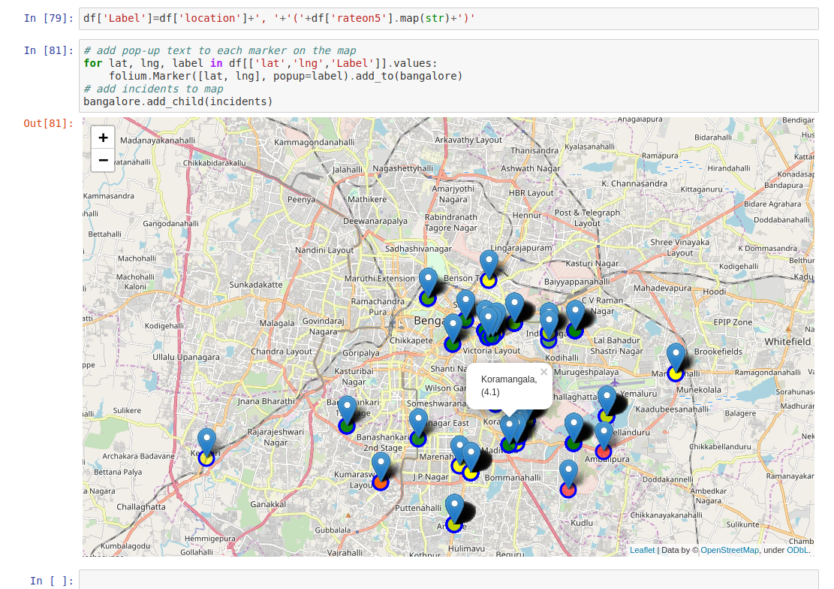

Conclusion:

From the above map, we can see that there are 3 clusters marked in green, yellow and pink, and to open a new cafe there are where we can get good customers would be between Ashok Nagar and Madiwala areas. There are more cafes in these 2 areas but we can see people from between these 2 areas have to travel a lot to go to these places.